1. Connect Purchases to Inventory

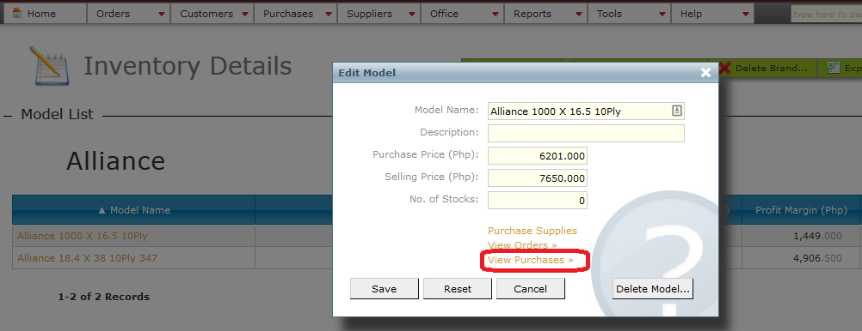

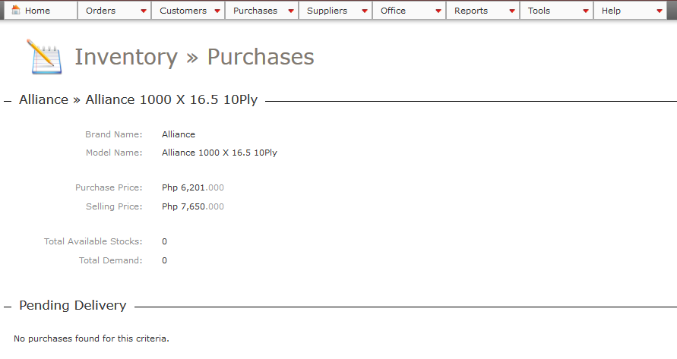

2. Check duplicate SI/DR in Purchases

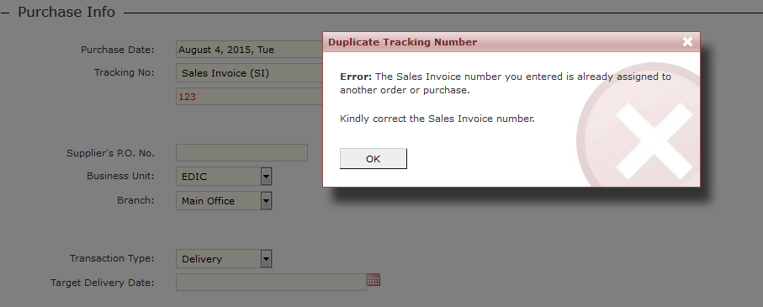

3. Show old stocks in drop-down. Old stocks are greyed.

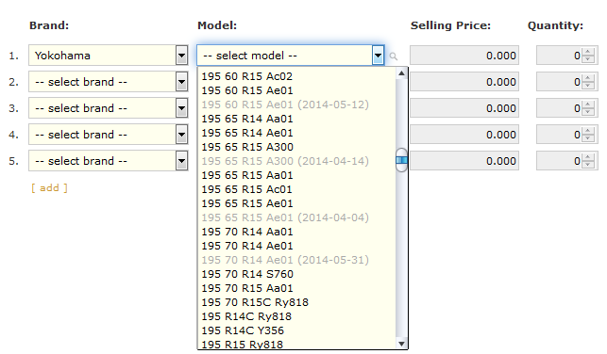

4. 3-decimal notation system to fix inconsistencies when rounding off and make system and paper records tally. Decimal part is greyed to make the amount more readable.

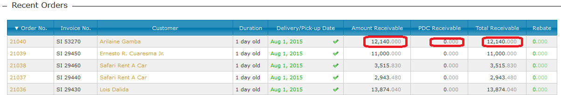

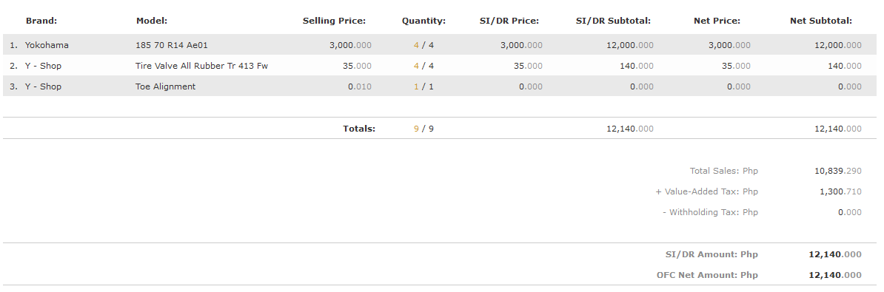

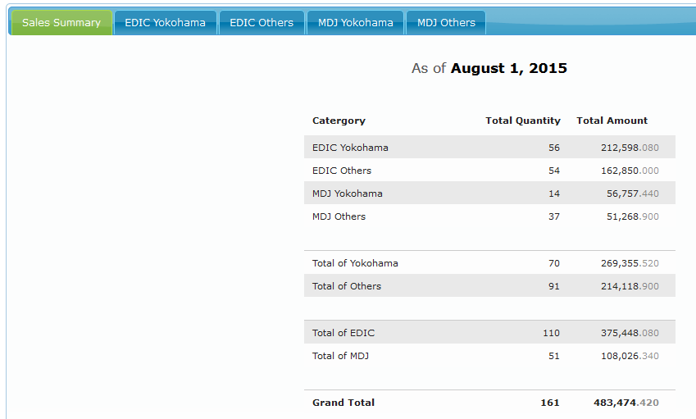

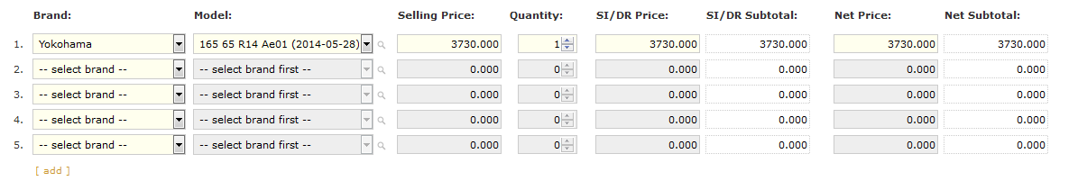

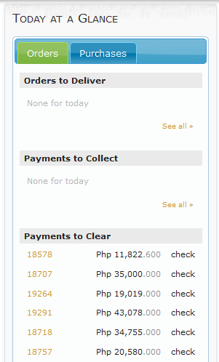

5. Added Remarks in payment. Payment is also set to Check by default.

